Susan Rakov: Advocacy Research for a Better World
By Paige Thesing

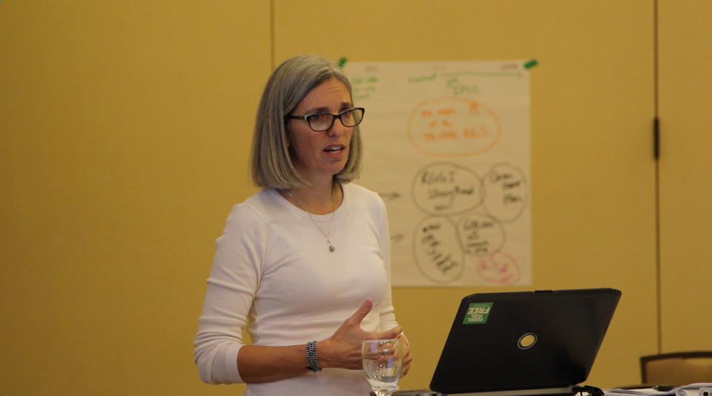
It was a sunny Santa Barbara Sunday when I visited the Rakov home. Every door and window was open, letting the sunshine and warmth spill into the living room. I sat on an antique Philippine Mahogany couch, surrounded by all sorts of nostalgic décor, from used instruments to faded family photos to child’s drawings from fifteen years ago. There was music playing somewhere. Laughter floated among the several people in the house. In the corner, a young woman was collaging next to the fireplace with a happy dog resting at her feet. It was a perfect lazy Sunday, and at the center of it was Susan Rakov.

The first thing you notice about Susan is her smile. With a single grin, she conveys such love and delight. Her joyful demeanor is infectious; it is hard to not be happy around her. She has a clear commitment and consideration for other people, which easily translates to her passion for civic work. As the founding director of Frontier Group, a research institute focused on environmentally and civically sustainable issue solutions, Susan has a clear dedication for creating a better world for everyone. Her early work as an activist and organizer allowed her to understand the need to work with the public towards beneficial issue solutions. With Frontier Group, Susan works to publish substantial research and data that illustrates the need for impactful policy solutions to address issues from public health to transportation to fair electoral practices. With years of experience in public outreach, organizing, and research, it comes at no surprise that politics has been in her life from the very beginning.

Susan Rakov was exposed to politics at an early age. With a mother who worked at NASA and a father who practiced law as a litigator at the Federal Communications Commission, civil work and government were a large part of her family’s life. Growing up in Newton, Massachusetts, a suburb of Boston, school was very important to Susan and her parents. A self-described “brainiac,” she further explored politics by studying Social Studies at Harvard University. After which, like so many other young, politically-minded individuals, she planned on attending law school. But at her first job as a paralegal in New York City, Susan quickly realized that she detested the environment. Surrounded by busy lawyers who seemed to only care about money rather than the work, she found the atmosphere depressing and decided to reassess her path. In search of work that would be helpful to people in a different way, she found herself at Mass PIRG, a Massachusetts state affiliate of the nationally-known Public Interest Research Group (PIRG). These U.S. non-profits utilize grassroots campaigning and direct activism to further political goals with a specific orient towards liberal and environmental policies. Susan began as a college campus organizer, working to register people to vote and to help students develop campaigns to pass through legislation.

Like many young people at the time, the reelection of Ronald Reagan in 1984 was a wake up call for Susan as an activist. “I realized that I wasn’t going to change the world in three months,” she recalled. “It was actually a great moment of training…because [that experience] hardens you.” The reelection of Reagan motivated Susan to continue her work with Mass PIRG, eventually climbing up the ladder to organize her first canvassing office in the federal PIRG office in Washington, D.C. during the summer of 1984. In this office, Susan organized numerous volunteers to go door-to-door, on campuses, and on the streets to fundraise and advocate policy. She quickly learned that canvassing was necessary to not only do the work PIRG advocated for, but it was also crucial for funding the canvas effort as a whole. Thus, her attitude became one of self-sufficiency and responsibility, and this, in conjunction with her work ethic, enabled her to succeed as an organizer within PIRG. However, she was still disenchanted with Washington, D.C., partly due to the Reagan administration, but also because of the constant racism she saw within the communities she canvassed. “It was horrible,” Susan remembers. “Just stuff that made you go ‘Oh, god. I don’t want to live in this kind of world.’ I didn’t want go to D.C. ever again.” After that summer canvassing experience, she returned to Massachusetts to continue with Mass PIRG in the fall of 1984.

The following three years were very “exciting…and generative.” Susan advanced several times within the PIRG network, working as an organizing director, a national recruitment director, and then eventually becoming the assistant to the Chairman of PIRG and her mentor, Doug Phelps. Due to the immense success Mass PIRG was experiencing, Doug, and subsequently Susan, were able to discuss PIRG’s further policy goals. Within the scope of national organizations, the PIRG network had an excellent reputation of grassroots organizing and canvassing. However, this meant that PIRGs got pegged as the people who did the grunt work, not work on issue solutions. “We had people in the states who were trying to set themselves up as advocates and get in to see the legislators…and talk about what we were prioritizing in that state, but they didn’t have any credential,” Susan remembered. “But if we provided them with some really good reports, or some policy white papers, they would have standing to enter the conversation.” So, she and Doug began working on ways to boost PIRG’s “intellectual profile.”

During this process, Doug traveled to California and fell in love with Santa Barbara. He quickly called Susan to set up shop in the area. “So I got on a plane. I landed at this little Disneyland airport in Santa Barbara and was like ‘What is this? This is weird.’ This is like the fourth time I’ve been to California…I had no exposure to this place…I was very dislocated.” With no experience in the Santa Barbara area, she found the cheapest place she could to start work; a house on the infamous Del Playa in Isla Vista. “It was kind of perfect. Except on Saturday nights, it was insane! But we had a really fun summer, even though we mostly worked all the time.” After the initial work during that summer, Susan returned to Massachusetts for a few months before moving to Santa Barbara permanently in 1996. During this voyage, Susan found an office in Downtown Santa Barbara for a proper workplace where Frontier Group was established, albeit rather under the radar. “For a long time, we were very quiet about Frontier Group as a public entity,” she recalled. “We were mostly like stealth research policy involvement.” So, when a Frontier Group writer published a report, they would continue to refer to themselves as a PIRG advocate in their bylines. Soon, Susan realized that their organization could be raising their own money from donors to do work that they thought needed doing that wasn’t necessarily where PIRG partnered groups were yet. So, Frontier Group “came out of the closet” in 2006, making a “splash” with their initial research. “We did a lot of data driven reports that people hadn’t done before.” Roughly twenty years later, Frontier Group has grown into a national institution renowned for their research publications and is frequently cited by media outlets like The Atlantic, Politico, and The New York Times.

When defining the model of Frontier Group, Susan explained “what we do, we call ‘advocacy research.’ It’s not research for the sake of research, it’s research to make a point.” Through study, reports, white papers and blog posts, Frontier Group publishes research on issues ranging from climate change to consumer protection to civic participation. Notably, Susan has built this organization without the use of “silos,” or employees that are single issue specialists. “I sort of stumbled into [that] because I didn’t have the budget to hire a bunch of PhD’s” she explained. “But I very quickly found out that I didn’t want anyone with a master’s degree because they can be totally inflexible.” As a result, Susan focuses on hiring people right out college with a variety of academic backgrounds. Additionally, all entry-level staffers are required to spend one summer canvassing, due to Frontier Group’s roots in activism and public outreach. It is important to Susan that the connection between Frontier Group and the public it serves is maintained, and canvassing allows that relationship to thrive. The extensive writing done by the organization also allows for accessibility. “We think of ourselves as a bridge between the data, the academic approach, and the public,” she explained. “We think about our audience as the inquiring or interested public as reached through the media.” It is in this way that Frontier Group’s issue research has created an image of a better tomorrow for all people.

Susan described Frontier Group’s goals confidently and eloquently. “We provide the information to illustrate the need for issue solutions. The issues that we work on are the ones that best illustrate the potential of this moment in history. And by that, I mean the potential for good and the potential for bad.” Susan envisions a future where mass consumerism is curbed, with activities focusing on “taking care of other people, building strong communities, and getting along with one another.” However, she understands the difficulties in achieving such practices. “It’s just going to demand…people living in unusual ways and trying unusual things. It demands people thinking differently about what their job here is on the planet. You know, their capital J ‘Job.’” Susan also recognizes that our country’s current state of political polarization is not helping move us forward. “Polarization is making it harder for anyone to address this core issue of ‘what is the world going to look like next?’” She added, resuming with enthusiasm. “It’s going to be really different, and I continue to think that there is a huge opportunity here.” When asked if future generations are able to enact this change, Susan is optimistic. “I feel like things that’s happening in Florida, for example, with high school students in the streets…that can be contagious,” she says, referring to the momentum continuing from the Parkland, Florida shooting. “It’s already very complicated, but looking at things like that…it just gives you some hope.”

