So, you think you’re an environmentalist?
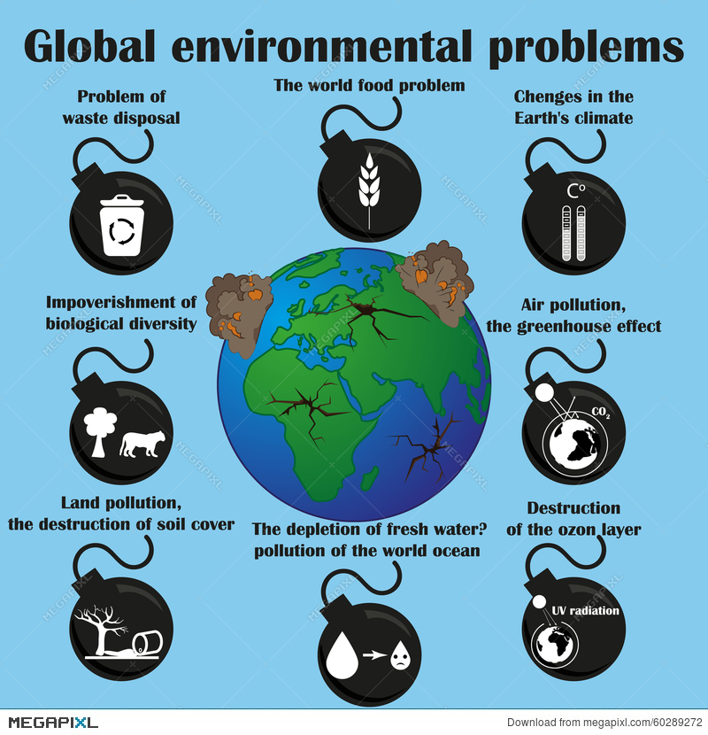

What is an environmentalist?
When people think of the term “environmentalist,” they often think of “tree-hugging, vegan, hippies” but little do they know, the term is so much more than that. What I consider to be an environmentalist may be different from what others believe it to be. An environmentalist is someone who has the goals of protecting the environment from further harm AND acknowledges the right to a healthy environment for every single person.

What is environmental justice?
Environmental injustice, according to the Environmental Protection Agency (EPA), is the fair treatment and meaningful involvement of all people regardless of race, color, national origin, or income, with respect to the development, implementation, and enforcement of environmental laws, regulations, and policies. Environmental justice will be achieved when everyone has the same degree of protection from environmental and health hazards and equal access to the decision-making process to have a healthy environment in which to live, learn, and work. Environmental justice is not just ensuring the safety of all citizens, nationally and internationally, but also ensuring that each citizen has an active voice in the implementation process of anything that can or will directly affect their community.

Do you consider environmental injustice to be part of the environmental agenda?
Environmental injustice is an issue that has been around for quite some time and the awareness on the issues could be, and should be, increased greatly. As an environmentalist, environmental justice should be a main concern. Yes, global warming is a problem that we should be concerned about. Yes, fracking and the increasing dependency on nonrenewable resources should be a concern. And yes, environmental injustice should be on the radar for environmentalists as well. There are plenty of problems that environmentalists are trying to combat, but that does not mean that a specific problem is less important than another. Each issue should be dealt with in an urgent manner and there should not be a priority to solve one before the other because they are all related.

How do we know that it is not just coincidental?
There is a theory called the Minority Move-In Hypothesis, where some argue that the inequities that these communities face are not a result of racism but rather are from market forces that made these areas less expensive. Thus, it was more attractive to people of color, who tend to have low incomes and less wealth than white folk. These areas are less expensive because the hazardous facilities have decreased neighborhood livability, which diminished land values. To simplify things, the hypothesis believes that people of color move into areas that have established hazardous facilities because rent is cheap from the consequences of the facility.
The Minority Move-in hypothesis has been proven to be incorrect. A survey that was taken by minority residents concluded that they may be even more concerned about environmental risks, especially with environmental justice being a big buzzword in selected communities. From a study conducted by Manuel Pastor, Jr., Jim Sadd, and John Hipp, they concluded that minorities attract toxic storage and disposal facilities (TSDFs) but TSDFs do not generally attract minorities. In other words, pollution follows people. Other studies have shown that facilities tend to be located in communities that are already heavily nonwhite and environmental/racial disparities have increased after people of color move in.

Is it really that big of a deal?
Yes, it is. Not only is this relevant towards the environment, but the issues may stem from environmental racism. Communities of color and poor communities often face disproportionate environmental risk and exposure. In a study conducted by the U.S. General Accounting Office study, three out of four commercial hazardous waste landfills in the Southeast are located in African American communities, while African Americans only make up 20% of the population. The United Church of Christ Commission on Racial Justice concluded that race was the most significant factor to determine the locations of hazardous waste sites in the U.S.

What can we do about it?
Spread awareness! The biggest thing you can do to get involved in the movement would be to increase awareness and join some volunteer organizations that are aimed to fight against environmental injustices. Public participation and action can play a big role in the implementation of policies if done correctly, as seen before in other historical movements.

As I said before, yes climate change and our dependence on nonrenewable are of concern and should be addressed by environmentalists and others worldwide, but we have to start considering other issues as well. I agree, we have to take care of the earth because there is only one, there is no plan B, but we also have to take care of the people who are living on this planet. How can we prioritize saving the earth when people, who cannot defend themselves or speak up against these injustices, are still suffering? We should come together as a whole and try to address all of these issues. Yes, there are a lot of problems that need to be solved, but if we all work together and make sure that each problem is receiving the same amount of dedication and effort, anything is possible.

