Isla Vista: What are the political implications of being an unincorporated college town?
By: Annie Bagdasaryan
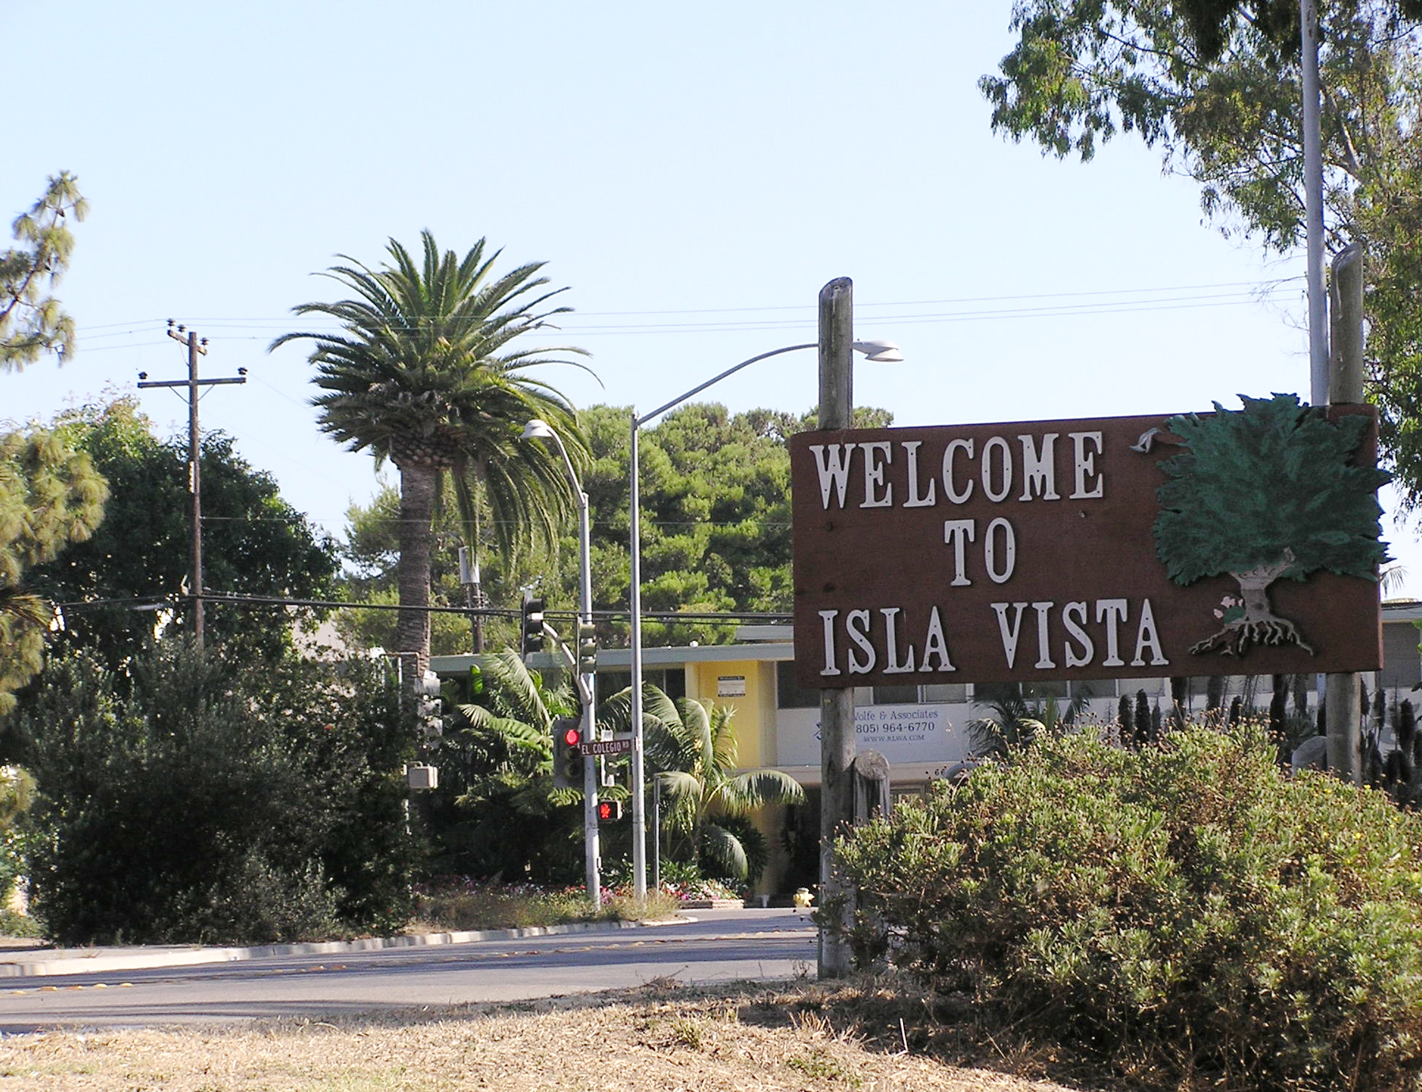
Source: Mak, Alan. “Welcome Sign in Isla Vista.” Ca.wikipedia.org. September 2005.

If you ask a resident of Isla Vista (IV) what city they live in, you will most likely get a conglomerate of different answers. The truth is, there is no correct answer to the question. This is because Isla Vista is defined as an unincorporated community. While IV is surrounded by major cities like Santa Barbara and Goleta, it does not belong to a specific municipality. This status of “incorporated” has become a defining aspect of Isla Vista, allowing for the community to take charge of how the area should be governed. However, this title has often times led to a lack of agency and responsibility concerning matters that negatively affect the locality.

What does “unincorporated” actually mean?

By law, an unincorporated area is commonly defined as a region of land that is not governed by a local municipal corporation. For those wondering what a local municipal corporation is, you are not alone. This legal term just refers to a city, town, village or borough that has governmental powers. States give these localities limited powers to govern their own areas. Unincorporated areas, however, are communities and areas that are outside the jurisdictional boundaries of incorporated cities. As such, they are not serviced by an incorporated area. Some of the mandatory functions of a municipality that do not extend to unincorporated areas include: land development, water and sewer, waste management, cemeteries and firefighting.

How did Isla Vista come to be an unincorporated area?

Prior to its label as a booming college town, Isla Vista was home to a thriving Chumash Indian settlement. By the end of the second world war, Isla Vista had transitioned from a Spanish settlement to an asphalt mining area. However, it remained almost completely underdeveloped. In 1948, the University of California Regents acquired a Marine base on the bluff to build a Santa Barbara campus. The official opening of UCSB in 1958 enticed Isla Vista landlords to receive zoning permits and create infrastructure that would bring in maximum profits from the new student-housing market. Throughout this process, Isla Vista was not adopted as part of a city or county. Instead, grassroots community efforts, business owners, and landlords made up the authority figures that shaped and maintained Isla Vista.

What problems did/do residents encounter as a result of living in an unincorporated area?

Without a formal local government to turn to, many residents of Isla Vista are often confused about where to turn to for a variety of different public issues. To name a few, lighting on streets and infrastructure remain pivotal problems in the town. However, as an unincorporated area, Isla Vista does not have the tax revenue needed to resolve these issues. Unlike an incorporated area, basic services might not be met because of a lack of accountability and funding. For example, while cities have local fire departments that service the citizenry, Isla Vista residents depend on Santa Barbara firefighters in the case of an emergency. This sometimes results in longer wait times because of the distance between Santa Barbara firehouses and Isla Vista. What seems more frustrating than the lack of basic services is the lack of representation when it comes to voicing these concerns. While Isla Vista has created many resource centers over the years to help with specific needs, there is no one government building or entity that people can turn to. Instead, residents are left to their own devices when it comes to seeking aid and guidance.

Who are the main providers of services in Isla Vista?

Isla Vista is managed primarily though the office of the Third District Supervisor of Santa Barbara. In collaboration with the Isla Vista Recreation and Parks District and law enforcement from the Isla Vista Foot Patrol, a decentralized form of government is brought to Isla Vista. UCSB’s close proximity to Isla Vista and the fact that the majority of IV residents are students gives the university motivation to occasionally intervene in Isla Vista politics. Problems in Isla Vista that garner public attention affect the reputation of the University, incentivizing UCBS’s increased involvement in bettering IV.

What role did the IV riots in 1970 play in bringing about community support for self-governance?

The Isla Vista riots of 1970 brought the community together and began an era of activism and grassroots politics. The riots were agitated by the student led burning of the Bank of America, which stood on the site of today’s Embarcadero Hall. The riot was in response to tensions from the Vietnam War, big business, and capitalism. After this, police cracked down in Isla Vista, using violence and tear gas to counter riots and radical groups. The riots changed the face of IV from a cute quaint town to a destroyed worn out area. However, the controversy directed attention on Isla Vista and how students were living, and led to the creation of many community organizations and grassroots movements whose goal was to rebuild morale and regain local control over the town.

What other attempts have been made at self-governance in Isla Vista’s past?

Isla Vista attempted to gain cityhood in the years of 1972, 1975, and 1983. The efforts were blocked by the Local Agency Formation Commission (LAFCO), which is in charge of reviewing applications for cityhood elections and other changes in the status of local governmental entities. LAFCO’s reasoning for denying the election for cityhood was because of a study commissioned by LAFCO that labeled Isla Vista as financially unfeasible. In 2001, the city of Goleta officially became a city, but cut Isla Vista out of the new city jurisdiction.

What are common conceptions of Isla Vista governance?

One of the biggest conceptions of Isla Vista is that it is the “unwanted child” of Goleta and the county of Santa Barbara. Since Goleta and Santa Barbara County do not take much accountability for what takes place in Isla Vista, it is assumed that no entity wants to take care of the community. Some current reasons for the lack of involvement include the controversial Deltopia riots, and the image of IV as a wild party town destined for self-destruction. The lack of formal taxation and revenue has led many to believe that Isla Vista will never attain the funds needed to provide the services that an incorporated area typically supplies. Moreover, statements released by influential sources have led public opinion about IV self-governance down a pessimistic path. IV has been labeled a “problem child” by newspapers such as SB Independent and has been named “an orphan” by representative Joan Hartman.

Who is currently responsible for making important decisions in Isla Vista?

Power dynamics in Isla Vista are divided between different influential stakeholders. These stakeholders include: property owners, non-profit organizers, government officials, student and staff liaisons from UCSB, and residents. Just last year, Isla Vista gained a new local government called the Community Services District (CSD). Prior to a the CSD, the main forms of government were the Isla Vista Recreations and Parks District (IVPRD) and the County of Santa Barbara. The CSD is a special district capable of levying a property tax to support providing services to its constituents. A few examples of these services include: water, sewage, policy, electricity, and garbage collection. Even though Isla Vista voters approved of Measure E on the ballot, which allowed for the formation of a Community Services District, the accompanying 8 percent utility tax ballot measure did not pass. The formation of the CSD occurred, but it does not have the financial support that the utility tax would have provided. In order to ensure that the CSD receives adequate funding, UCSB has pledged to donate $200,000 each year for seven years. The CSD is now officially established as a seven-member governing board, made up of five elected members and two appointed seats.

How does the CSD differ from a city?

The most important distinction between IV CSD and a city is that cities can make laws while CSDs cannot. Cities also have more responsibilities, such as providing policing and jail services.

What powers does the CSD have?

The CSD has eight primary powers that it prioritizes. These powers comprise of the: Municipal Advisory Council, Area Planning Commission, Graffiti abatement, Parking district, Landlord-tenant mediation services, Community policing, Gutter and sidewalk infrastructure improvement, and maintenance and management of community facilities.

Does the CSD hold a promising future for the current and future residents of Isla Vista?

The CSD has been Isla Vista’s first impactful step towards self-governance. The district remains an experiment that is attempting to provide small-scale governance and allowing for students to be involved in the process. The future of the CSD remains unpredictable, mainly because of the lack of financial security that is needed to meet new and existing goals. The question of CSD’s future lays partially in the hands of residents. For those that wish to learn about how the society they live in operates or speak out about issues that they believe need reforming, the CSD provides a place to go. The IV CSD meets every second and fourth Tuesday at 6pm in the Community Conference Room, 970 Embarcadero Del Mar. For the first time in Isla Vista’s history, the fate and movement behind self-governance lies in the hands of the people it affects the most, the residents.

