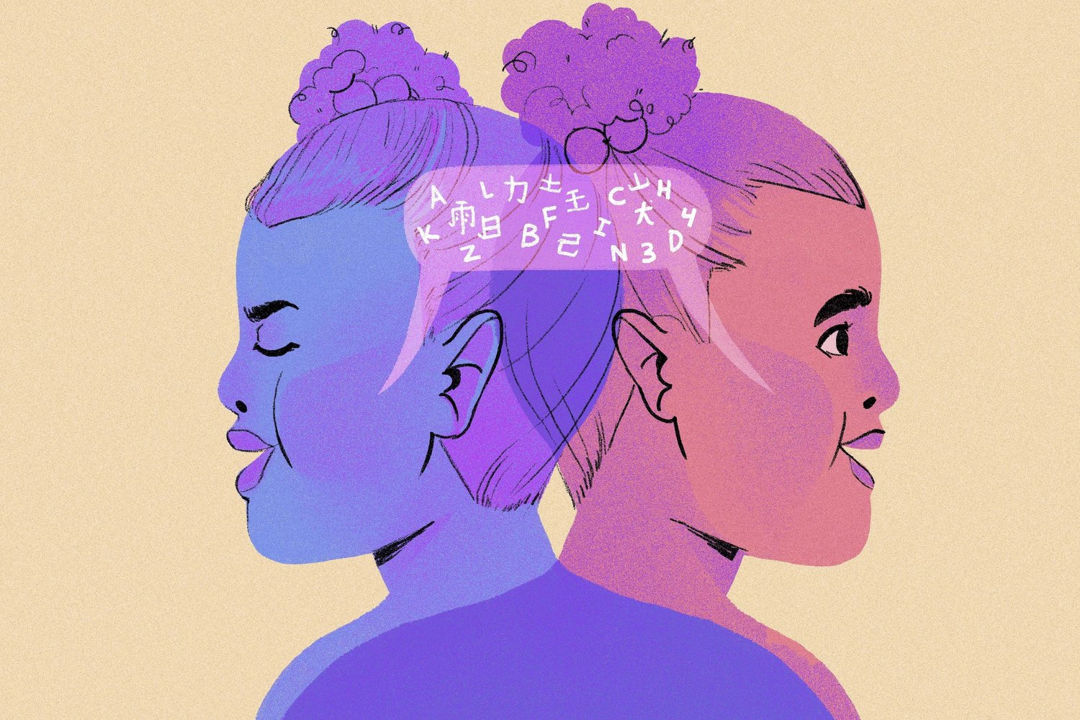
Why Can’t Immigrants Just Learn English?
The United States is currently experiencing the largest wave of child immigration in its history and there is not enough supporting educational infrastructure. Children of immigrants constitute the largest minority and the fastest growing segment of the U.S. child population. In 1990, one out of seven children were from an immigrant family, in 2010 one out of five children had such a background, and it is estimated that these figures will rise to one out of three children by the year 2020. The United States is currently experiencing the largest wave of child immigration in its history and there is not enough supporting educational infrastructure. There is a significant three-way overlap between Latino, dual language, and immigrant children in the United States. In fact, the majority of immigrant families and children in the U.S. are Latino. Most immigrant families speak a language other than English at home (most commonly Spanish) and a large proportion of children in America grow up using two languages. The past three decades have seen a rapid increase in Latinos in the U.S, with their numbers more than tripling from 1970 (10 million) to 2000 (35 million). Latino children are already the largest minority group in schools. Bilingual education has been a surprisingly contentious issue in California and recently in 2016 voters decided to vote yes to integrate a measure that allows students to be exposed to more than one language. However, what does this mean exactly?
Who Are These Immigrant Children?
The majority of children from immigrant families are “second-generation immigrants”, that is, born in the U.S. to one or two foreign-born parents. Most U.S. Latino youth are young (median age 12.8) and from the second generation (52%). Despite their young age and growing numbers, empirical research addressing the development, wellbeing and mental health of children of immigrants is lacking, with most of the work focused on adolescents and adults. Hundreds of thousands of people around the world desperately wish to leave their homelands and travel to the United States for a variety of reasons. Often, their dreams for a new life parallel the motivations that caused the Pilgrims to leave their own homelands for America. However, immigrants often meet challenges upon their arrival that they never anticipated. These difficulties range from navigating legal complications to understanding complex transportation systems, securing living arrangements and employment, battling culture shock, psychological distress, depression and despair. Unfortunately, the national ethos of the American Dream is too ambiguous with its recommendations of securing prosperity and success, as well as an upward social mobility.
What Has Been Done in the Past about Bilingual Education?
The landmark 1974 U.S. Supreme Court decision Lau v. Nichols aimed to make that school transition easier for young people who speak English as their second language. That decision relied on the prior 1954 Brown v. Board of Education decision and the Civil Rights Act to force all school districts receiving federal funding to establish multilingual programs to ensure all students have equal educational opportunities, regardless of their national origin. When advocates discuss the “school-to-prison pipeline,” they often reference the fact that African-American students are far more frequently sent home from school as a disciplinary measure than white students. Sometimes overlooked in that discussion is that Latino immigrant students fare pretty badly in that pipeline, as well. The Lau case was created, in part, because the children of Chinese families were too often falling into disciplinary trouble with schools in the 1970s. The National Asian Pacific American Legal Consortium wrote in recognizing Lau’s legacy that these inadequacies caused difficulties and frustration among the LEP Chinese-speaking students, resulting in increased rates of truancy, delinquency, and drop-outs within an ethnic group that had previously been considered a model minority. The overall message sent by Lau is an important one.
In 2016, California voters officially ended the era of English-only instruction in public schools and lifted restrictions on bilingual education that had been in place for 18 years. Proposition 58 passed by a 73-27 percent margin. While its main sponsor Senator Ricardo Lara says the new law does not mandate bilingual education, school districts will be able to decide locally whether they want to offer bilingual education or not based on parents' demand for it. Under the new measure, if at least 20-30 parents want bilingual instruction for their children, their school will have to provide it. Even if less than 20 parents want it, they could put pressure on schools to make and force school district officials to intervene and come up with an accommodation. The main change under Proposition 58 is that parents no longer have to sign a waiver in order to enroll their children in a dual language or bilingual classroom. Under English-only policies, teachers were prohibited from making any recommendation on bilingual education, so that could change too.
California is home to 1.4 million English language learners which comprises about a fifth of the states' total student enrollment. This decision would allow them to enroll in bilingual classes in where they are taught in their native language and gradually make the transition to English. They would also have the option of enrolling in dual-language programs in which students are taught all their courses in two languages at the same time. This highlights the issue of the shortcomings in educating English language learners (ELLs) under English-only policies. In 2015 the U.S. Justice Department found that California had failed to address the high failure rates of tens of thousands of ELLs. As a result, state education officials agreed to new training and monitoring procedures to ensure that districts provide the necessary services and interventions required under the federal Equal Educational Opportunities Act. To that end, bilingual education and dual language instruction will now become part of the mix of instructional options educators will have to appease parents and improve the quality of instruction ELLs receive on their way to English proficiency.
Conclusion
It is problematic to think that children born outside of the United States can participate equally in the nation’s school system if they can’t understand teachers’ instructions and materials. It generally takes five to seven years to be proficient in a second language. Second-generation Hispanic children raised in the United States usually learn to speak English very well by adulthood, even though three-quarters of their parents speak mostly Spanish and are not English proficient. However only 23 percent of first-generation immigrants from Spanish-speaking countries — those that began learning later in life, say they speak English very well. Pew Hispanic Center statistics have shown that 88 percent of the members of the second generation — those children that were introduced to English at an early age, described themselves as strong English speakers. This phenomenon should apply to children who speak English as their first language as well. In other words, U.S. students should be introduced to a second language at a young age in order to be fluent by adulthood.

Bibliography
“California will bring back bilingual education as Proposition 58 cruises to victory.” Los Angeles Times, Los Angeles Times, www.latimes.com/nation/politics/trailguide/la-na-election-day-2016-proposition-58-bilingual-1478220414-htmlstory.html
“FindLaws United States Supreme Court case and opinions.” Findlaw, caselaw.findlaw.com/us-supreme-court/414/563.html.
“From Lau v. Nichols to the Affordable Care Act: Forty Years of Ensuring Meaningful Access in Health Care for Limited English Proficient Asian Americans, Native Hawaiians, and Pacific Islanders.” Asian American Policy Review, 17 Apr. 2017, aapr.hkspublications.org/2014/05/31/233/.
Kamenetz, Anya. “6 Potential Brain Benefits Of Bilingual Education.” NPR, NPR, 29 Nov. 2016, www.npr.org/sections/ed/2016/11/29/497943749/6-potential-brain-benefits-of-bilingual-education.
Levitan, Joe. “Bilingual Students Need Support in Their Native Language.” Education Week, 8 Feb. 2017, www.edweek.org/ew/articles/2015/05/13/bilingual-students-need-support-in-their-native.html.
Lynch, Ed.D. Matthew. “Why Bilingual Education Should Be Mandatory.” The Huffington Post, TheHuffingtonPost.com, 16 Nov. 2014, www.huffingtonpost.com/matthew-lynch-edd/why-bilingual-education-s_b_6168638.html.
“The Importance of Bilingual Education.” The Importance of Bilingual Education | U.S. Department of Education, 25 Mar. 2016, www.ed.gov/news/speeches/importance-bilingual-education.

